#搜索引擎中在索引rooms中新增了一个type，名为house,借助es的head插件创建house，无需写脚本执行，做法如下:#

1、登录线上es的head插件画面 http://192.168.30.123:9200/_plugin/head/

2、切换到复合查询

3、输入正确的url及建表属性：如图

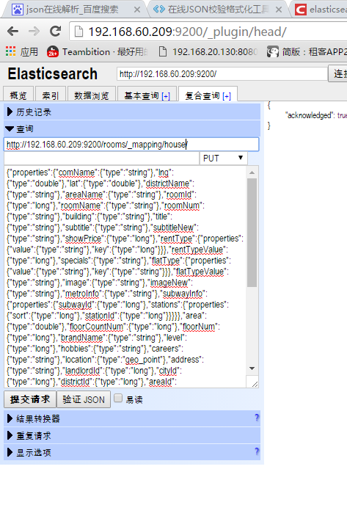

以下是建表属性：

{"properties":{"comName":{"type":"string"},"lng":{"type":"double"},"lat":{"type":"double"},"districtName":{"type":"string"},"areaName":{"type":"string"},"roomId":{"type":"long"},"roomName":{"type":"string"},"roomNum":{"type":"string"},"building":{"type":"string"},"title":{"type":"string"},"subtitle":{"type":"string"},"subtitleNew":{"type":"string"},"showPrice":{"type":"long"},"rentType":{"properties":{"value":{"type":"string"},"key":{"type":"long"}}},"rentTypeValue":{"type":"long"},"specials":{"type":"string"},"flatType":{"properties":{"value":{"type":"string"},"key":{"type":"string"}}},"flatTypeValue":{"type":"string"},"image":{"type":"string"},"imageNew":{"type":"string"},"metroInfo":{"type":"string"},"subwayInfo":{"properties":{"subwayId":{"type":"long"},"stations":{"properties":{"sort":{"type":"long"},"stationId":{"type":"long"}}}}},"area":{"type":"double"},"floorCountNum":{"type":"long"},"floorNum":{"type":"long"},"brandName":{"type":"string"},"level":{"type":"long"},"hobbies":{"type":"string"},"careers":{"type":"string"},"location":{"type":"geo_point"},"address":{"type":"string"},"landlordId":{"type":"long"},"cityId":{"type":"long"},"districtId":{"type":"long"},"areaId":{"type":"long"},"stationId":{"type":"long"},"subwayId":{"type":"long"},"communityId":{"type":"long"},"houseType":{"type":"long"},"brandType":{"type":"long"},"roomMateGender":{"type":"long"},"roomMateCnstl":{"type":"string"},"readyDate":{"type":"long"},"decoration":{"type":"string"},"toilet":{"type":"long"},"veranda":{"type":"long"},"bayWindow":{"type":"long"},"airCond":{"type":"long"},"tv":{"type":"long"},"hasPic":{"type":"long"},"hasWifi":{"type":"long"},"orientation":{"type":"string"},"roomScore":{"type":"double"},"flatTag":{"type":"long"},"hasService":{"type":"long"},"label":{"type":"long"},"roomCount":{"type":"long"},"checkInTime":{"type":"string"},"attributeConfig":{"properties":{"value":{"type":"string"},"key":{"type":"string"}}},"statusUpdateTime":{"type":"string"},"checkInTimeStr":{"type":"string"}}}